Curriculum Vitae (C.V.)
- Personal data:
Name (Arabic) | اسماء احمد محمد احمد
Name (English) | Asmaa Ahmed Mohamed Ahmed
Department | Rheumatology rehabilitation and physical medicine.
College | Faculty of medicine
Academic degree | Assistant lecturer.
Office Address | Banha University Hospitals
Mobile 1 | 01030016177
Home phone | 0133379395
Work phone | 00201116168356
Email (university)
Email (alternative) | Asmaaelbenhawy05@gmail.com
Web site (if any) | --------
Recent Photo (passport format) | 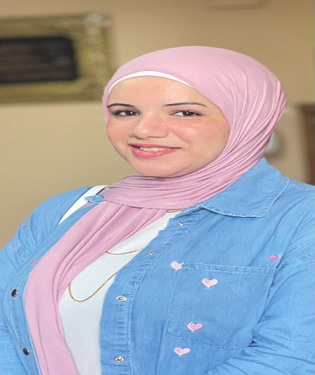
- Education:
  - Degree obtained;
Institution | Degree obtained | Year
Banha Faculty of medicine | M.B.B.CH. | 2015
Banha Faculty of medicine | M.S.C | 2022

  - Specialty;
General specialty. | Rheumatology rehabilitation and physical medicine
Specific specialty. | Rheumatology rehabilitation and physical medicine

  - Language skills (Excellent, Very Good, Good or Basic);

Language | Reading | Speaking | Writing
Arabic. | Excellent | Excellent | Excellent
English. | Excellent | Good | Excellent
French. | Good | ----------------- | ----------------
Other (specify).

- Positions:
Tittle | Year | University/Institution
House officer | 2015-2016 | Banha faculty of medicine
Resident | 2018-2021 | Banha faculty of medicine
Demonstrator | 2021-2022 | Banha faculty of medicine
Assistant lecturer | 2022 till now | Banha faculty of medicine

- Membership of institute (List):
Egyptian Society of Rheumatic Diseases.
Egyptian Rheumatology and Rehabilitation.
Egyptian Society of Rheumatology and Rehabilitation.
Egyptian College of Pediatric Rheumatology.
- List of Publications:
Comparative Study between Rheumatoid Arthritis and Osteoarthritis regarding Associations of sleep disturbances with Disease Status
Asmaa A. Mohamed a, Samia M. Abdelmonem a, Abdelwahab S Eldien, Rasha M .Fawzy.

14. Attended Workshops, Symposiums, and Conferences: "List name and year";

Name of Workshops, Symposiums, and Conferences | Year
- New ERA and updates of Physical medicine, Rheumatology and Rehabilitation, Agouza Rheumatology and Rehabilitation center Armed Forces, Cairo, Egypt.  - The 4th Benha conference of Rheumatology, Rehabilitation and Physical medicine, Al-Qalyubia, Egypt.  - The 18th Annual Ain Shams International Rheumatology and Rehabilitation conference, Cairo, Egypt.  - Basic musculoskeletal ultrasound workshop of wrist and knee joints  (trainee) on the side of the 11th Annual medical conference of Benha Faculty of Medicine, Al-Qalyubia, Egypt. | 2023  2023  2023  2024  2024
Benha University.  - The 5th Benha conference of Rheumatology, Rehabilitation & Physical Medicine Department.  - The 45th annual meeting of the Egyptian society of rheumatic diseases,Hurgada; Egypt.  - Basic Nerve Conduction and Electromyography workshop  - (organizing committee), medical skills and simulation center, Benha University.  - The 3rd international Agouza Physical medicine, Rheumatology and Rehabilitation center conference, Armed Forces, Cairo, Egypt. | 2024  2025  2025

